Profile of
Indonesian Accreditation Agency for Higher Education in Health (IAAHEH)

The Indonesian Accreditation Agency for Higher Education in Health (IAAHEH) which in Bahasa Indonesia is called LAM-PTKes, is an independent body that started to operate in March 2015. The agency’s development was facilitated by the Directorate General of Higher Education, Ministry of Education and Culture through Health Professional Education Quality (HPEQ) project from 2009 until 2014.

The legal foundation of LAM-PTKes are the following laws and regulations:

1. Law No. 12 year 2012 regarding Higher Education, article 55, paragraph 5 which mentions that
accreditation of study program as a form of public accountability is carried out by independent
accreditation agencies;

2. Minister of Research, Technology and Higher Education Decree No.32 year 2016 on
Accreditation for Study Programs And Institutions;

3. Minister of Education Decision No.291/P/2014 on Recognition of LAM‐PTKes;

After HPEQ project, as an independent accreditation agency, LAM-PTKes is funded through the accreditation fees collected from the study programs without Government subsidy. LAM-PTKes is supervised and audited every year by the National Accreditation Board for Higher Education (BAN-PT), which develops the country’s accreditation system.

One of the project’s significant contributions was the facilitation of 7 health profession organizations and their corresponding 7 associations of health education institutions (medicine, dentistry, nursing, midwifery, nutrition, pharmacy and public health) to pioneer the creation of an accreditation agency for higher education in health. They became the governing body of LAM-PTKes.

The establishment of LAM-PTKes is a landmark for Indonesia as this is the first time an independent accreditation agency is set up and is authorized to conduct accreditation for study programs in various health professions. This endeavor may be the first of its kind since most countries have an accreditation body for one particular health profession only. Other professions are currently preparing to establish independent accreditation agencies (such as engineering, psychology and accountancy). Therefore, LAM-PTKes is viewed as a role model for other professions.

LAM-PTKes’ Vision:

“To ensure global standards of quality for higher education in health”

LAM-PTKes’ Mission:

“To implement national accreditation of higher education in health that is sustainable and trustworthy”

LAM-PTKes’ Objectives:

- Development of accreditation policies, standards, instruments, and procedures for higher education in health to be implemented by IAAHEH;

- Quality improvement of study programs accredited by IAAHEH;

- Integration of accreditation of academic, vocational, and profession levels of education to improve competencies of health workers comperehensively;

- Competency of students graduating from study programs accredited by LAM-PTKes that meet standards and needs of society;

- Financial independence of LAM-PTKes to operate.

LAM-PTKes’ workload of study programs that need to be accredited in five years interval can be seen in the following table below.

Table 1: Number of Health Study Programs in Indonesia to be Accredited by LAM-PTKes

Level  Discipline | Vocation |  | Academic | Profession | Specialist | Master | Doctorate | Total
Level  Discipline | D3 | D4 | S1 | Profession | Specialist | S2 | S3 | Total
Medicine | - | - | 74 | 74 | 213 | 23 | 11 | 395
Dentistry | - | - | 31 | 31 | 37 | 7 | 5 | 111
Nursing | 445 | - | 277 | 277 | 5 | 15 | 1 | 1020
Midwifery | 682 | 38 | 3 | 3 | - | 7 | - | 733
Pharmacy | 124 | - | 116 | 29 | - | 16 | 5 | 290
Nutrition | 44 | 20 | 45 | 3 | - | 8 | 2 | 122
Public Health | 79 | - | 185 | - | - | 44 | 5 | 313
Other Discipline | 420 | - | - | - | - | 4 | 1 | 425
TOTAL | 1794 | 58 | 731 | 417 | 255 | 124 | 30 | 3409

Source : PD Dikti, 2015

Explanation:
D3: Vocational study program at Level 5 of the Indonesian Qualification Framework (IQF);
D4: Vocational study program at Level 5 IQF;
S1: Academic study program (Bachelor) at Level 6 IQF;
Profession: Level 7 IQF;
Specialist: Level IQF;
S2: Academic study program (Masters) at Level 8 IQF;
S3: Academic study program (Doctorate) at Level 9 IQF;

The number of study programs already accredited by LAM-PTKes and their rank can be seen in Table 2 below.

Table 2: Rank of Study Programs Already Accredited by LAM-PTKes by August 2016

No | Division | A |  | B |  | C |  | Total
No | Division | Academic | Profession | Academic | Profession | Academic | Profession | Academic | Profession
1 | Medicine | 6 | 5 | 13 | 8 | 3 | 2 | 22 | 15
2 | Dentistry | 6 | 3 | 5 | 5 | 0 | 0 | 11 | 8
3 | Nursing | 5 | 2 | 184 | 60 | 98 | 29 | 287 | 91
4 | Midwifery | 3 | 0 | 113 | 0 | 88 | 0 | 204 | 0
5 | Pharmacy | 5 | 0 | 20 | 0 | 20 | 0 | 45 | 0
6 | Nutrition | 1 | 0 | 7 | 0 | 4 | 0 | 12 | 0
7 | Public Health | 1 | 0 | 11 | 0 | 2 | 0 | 14 | 0
8 | Other Discipline | 2 | 0 | 15 | 0 | 5 | 0 | 22 | 0
 | Total | 29 | 10 | 368 | 73 | 220 | 31 | 617 | 114
 | Total Rank | 39 (4,62%) |  | 441 (60,07%) |  | 251 (35,31%) |  | 731 (100%)

Indonesian Accreditation Agency For Higher Education In Health (IAAHEH/ LAM-PTKes)
Address : Jalan Sekolah Duta 1 No. 62, RT 003, RW 014, Kelurahan Pondok Pinang,
Kecamatan Kebayoran Lama, Jakarta Selatan 12310
Phone: +62 21 3417 3304; +62 21 769 0913;
Website: www.lamptkes.org;
E-mail: sekretariat@lamptkes.org

IAAHEH’s Governance

Structure Organization
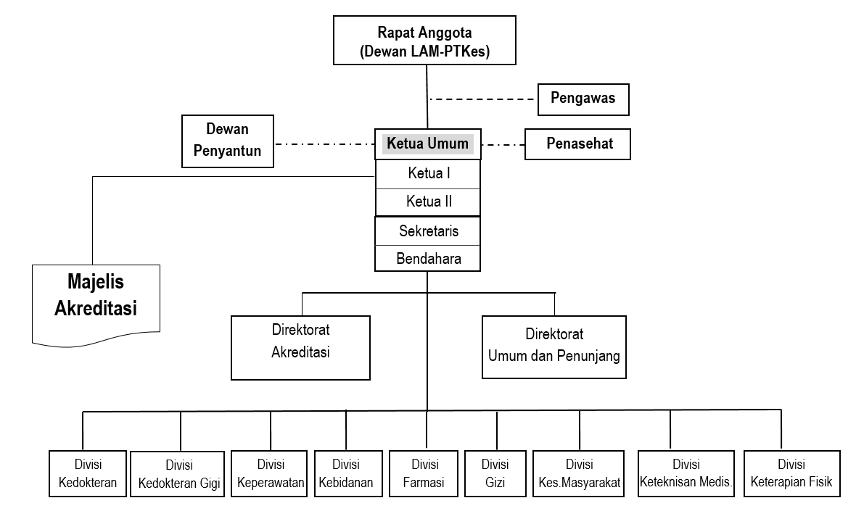
Board of Trustee
Quality Assurance
Adviser
Sponsor
President
Accreditation Director
Secretary
Finance and Resource Director
Directorate Accreditation
Directorate Public and Resources
Medical Division
Dental Division
Nursing Division
Midwifery Division
Nutrition Division
Pharmacy Division
Public Health Division
Another Health Dicpline
Council of Accreditation

The IAAHEH organization structure consist of :
- IAAHEH Board of Trustee that include 14 representative from seven professional organization and seven from Professional Education Association.
- IAAHEH Executive Board.
- President : Prof. dr. Usman Chatib Warsa, Ph.D., Sp.MK (K)
- Accreditation Director : Dr. Soetrisno, M.A
- Secretary : dr. Soedarmono Soejitno, M.Sc., DLSHTM
- Finance and Resources Director : Dra. Nursamsiah Asharini, M.Si
- Accreditation Team
- Head of Divisions.
- Medical Division : Prof.DR.Dr.Wahyuning Ramelan, Sp.A
- Dental Division : drg. Afi Savitri Sarsito, SpPM
- Nursing Division : Prof. Dra. Setyowati, S.Kp., M.App.Sc., Ph.D
- Midwifery Division : Laurensia Lawintono, MSc
- Public Health Division : Dr. Dra. Dewi Susana, MSc
- Pharmacy Division : Prof. Dr. Yahdiana Harahap, M.S.
- Nutrition Division : Dr.Ir. Budi Setiawan, MS
Each divisions have to manage accreditation of the study programs that relevant to the discipline.
- Council of Accreditation
There are 15 persons as representative from a professional organization and educational profession that elected to be a member of council.
- The Evaluator Team, consist of:
- Facilitators;
- Assessors;
- Validators.

Table 1. : The Evaluator Team for Accreditation in IAAHEH
Study Programs’ Type | Evaluators
Study Programs’ Type | Facilitators | Assessors | Validators
Medicine :  - Generalist  - Specialist | 9  9 | 47  104 | 10
Dental :  - Generalist  - Specialist | 5  5 | 25  3 | 5
Nursing:  - Vocational  - Profession | 15  17 | 8  14 | 51  60
Midwifery: | 19 | 75 | 2
Pharmacy: | 10 | 40 | 11
Nutrition: | 5 | 34 | 4
Public Health: | 12 | 33 | 6
Total | 106 | 383 | 149
The Team are:
- Facilitators :
- Medical Division’s Facilitators : 18 Facilitators
- Dental Division’s Facilitators : 10 Facilitators
- Nursing Division’s Facilitators : 17 Professional Nurses’ and 15 Vocational Nurses’ Facilitators
- Midwifery Division : 19 Facilitators
- Pharmacy Division : 10 Facilitators
- Nutrition Division : five Facilitators
- Public Health Division : 12 Facilitators
- Assessors :
- Medical Division’s Assessors (General Practitioner and Specialist) : 47 GP and 104 Specialist Assessors
- Dental Division’s Assessors (Dentist and Specialist) : 25 Dentists and 3 Specialist Assessors
- Nursing Division’s Assessors (Professional Nurse and Vocational) : 14 Professional Nurses’ and 8 Vocational Nurses’ Assessors)
- Midwifery Division : 75 Midwives Assessors
- Pharmacy Division : 40 Pharmacists Assessor
- Nutrition Division : 34 Nutritionist Assessors
- Public Health Division : 33 Assessors
- Validators
- Medical Division’s validators : 10 validators
- Dental Division’s validators : five validators
- Nursing Division’s validators : 111 validators
- Midwifery validators : two validators
- Pharmacy Division : 11 validators
- Nutrition Division : four validators
- Public Health Division : six validators

- Administration and Secretariat
JOB DESCRIPTION
1. Functions
- IAAHEH Board of Trustee’s function are:
- Develop Basic Regulation of IAAHEH;
- To Elect and discard the member of IAAHEH Executive Board;
- To Elect and discard the member of Accreditation Team;
- Approval the changing Basic Regulation;
- Approval of Operational Regulation and its changing;
- Approval of annual report and annual plan
- Approval of working plan and budget plan of IAAHEH
- IAAHEH Executive Board’s function are :
- To manage and leader daily activities of IAAHEH
- To meet the goal of IAAHEH by:
- Establishment of IAAHEH’s working plan or action plan;
- Implement the action plan;
- Propose new action to increase the performance of organization;
- Develop annual action plan or working plan;
- Monitor and evaluate the implementation of action plan and its achievement;
- Manage of resources;
- Manage and decide the Facilitators, Assessors, and Validators;
- Manage continuing budget;
- To develop and organize MoU with National and International institutions;
- Publish accreditation certificate for the health study programs;
- Approval the operational regulation of accreditation;
- Develop the system of accreditation for health higher education;
- To guide the health study programs based on the result of accreditation;
- Advocate the accreditation regulation of health study programs;
- To establish the inter professional of health providers and relation between sectors;
- To decide or reject the MoU with another institutions.
- The Chairman responsible to manage budget of IAAHEH and manage the resources.
- Secretary responsible for manage administration.
- Finance responsible to manage the IAAHEH’s budget
- Adviser
The role and Function of Adviser are :
- Advice to the Board in running this business;
- Supervise and direct the implementation of Programs and the Board’s activities
- Head of Divisions
The Role and functions are :
- Propose the draft policy, procedure, and accreditation instruments of health study programs according to their discipline.
- Develop criteria and the tools for accreditation based on their discipline.
- Monitor and evaluation process and outcome of study program accreditation based on their discipline.
- Monitor the follow up of recommendations based on the accreditation result according to discipline.
- Propose recruitment, training and development of the skill and knowledge of facilitators, assessor, validator and another team that useful for the development of IAAHEH capacities.
- Council of Accreditation
The function are:
- Decide the accreditation status of study programs and the level of accreditation status.
- Evaluate the appropriateness of study programs argumentation about the level of accreditation status to be actionable.
- Give input to the development of process accreditation
- Facilitators
The function are:
- Develop plan to support and guiding to the study programs.
- Communicate by online with the study programs about standard accreditation
- Build the report of guiding result.
- Assessors
The function are:
- Assess and evaluate the accreditation documents of study programs by doing desk evaluation.
- Verify, validate and evaluate the study programs performance by site visit.
- Compile the report of the result and discuss with the study programs and institutions.
- Report writing the recommendation to improve the study programs.
- Validator
The function are:
- Validate the score and its description that submitted by Assessors.
2. The Rules and Human Resources Management Systems
2.1. Planning and Recruitment
- Human resources plan: type and amount of the IAAHEH’s staff and management base on the job analysis, the workload.
- Recruitment: is done based on the eligible criteria and openly.
Table 2. IAAHEH’s Human Resources per December 31st 2015
The Job Position | Total
Boards | 5
Head of Divisions | 7
Assistant for Board of Board and Founder | 1
Assistant for Secretary | 2
Accreditation Staff | 4
Administration Staff | 2
Finance Staff | 3
HRD Staff | 1
IT Staff | 1
Supporting Staff | 3
Security | 1
Total | 30

2.2. Human Resources Development
- It is done by regularly training based on the need of the job position.

2.3. Remuneration
- IAAHEH staff remuneration based on responsibility and the workload.

3. Financial Management
3.1. Accounting Policy
The proposal of budgeting in every activities should be based on the operational plan. And should be proposed at least two weeks before activities. The proposal including:
- Letter of assignment,
- The report of validated work result;
- Proposal should be validated from accreditation section and the president.

3.2. Budgeting and Its Realization

Annual work plan with the budgeting prepared and coordinate by the IAAHEH Secretary. The Annual Work Plan have to be write according to the activities plan that written in the feasibility study which include accreditation, infestation, socialization, Monitoring and Operational.
Every sections have to submit to the Secretary about their annual work plan which include frequencies, volume for the next year on October every year. The work plan also have to give attention the activities in the current year.
All the work plans will be compiled by the Secretary then discuss in the meeting of the Board of Trustee. The result of the meeting is final decisions then will be implemented.

