Announcement of the 2021 APQN Academic Conference (AAC) Webinar
Dear APQN members and participants,
Greetings from APQN!
As we continue to adapt to combatting against COVID-19, the APQN executive and organising committee has decided that the APQN Academic Conference (AAC) and Annual General Meeting (AGM) will be a two-part event across 2021 and 2022. This will allow us to reconnect with one another – sharing our expertise and experiences to tide us over until we can meet again in-person. We hope that the opportunity will come once again in 2022.

The first event will be a free webinar on Thursday, 25 November 2021 from 4-7pm (GMT+8) and both APQN and EduValue will be sponsoring the Event so as to allow as many participants to join. This will be an opportunity for us to listen to our keynote speakers as well as paper presentations. Below is our main theme and sub-themes.
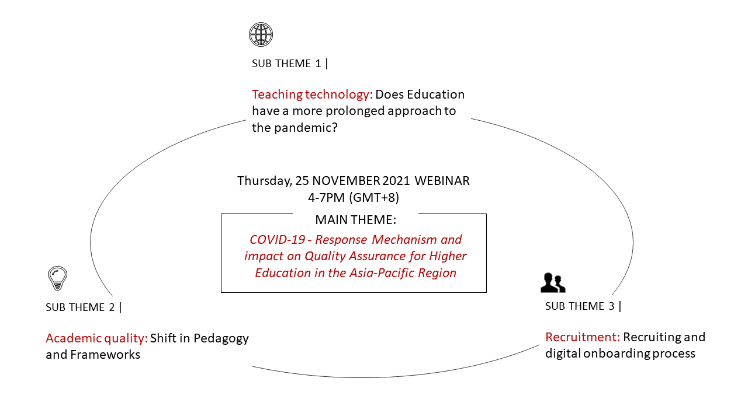
The second event will be a conference in Singapore and will tentatively be held from 24-27 November 2022. We hope to share and engage with you in-person on the following themes and sub-themes.
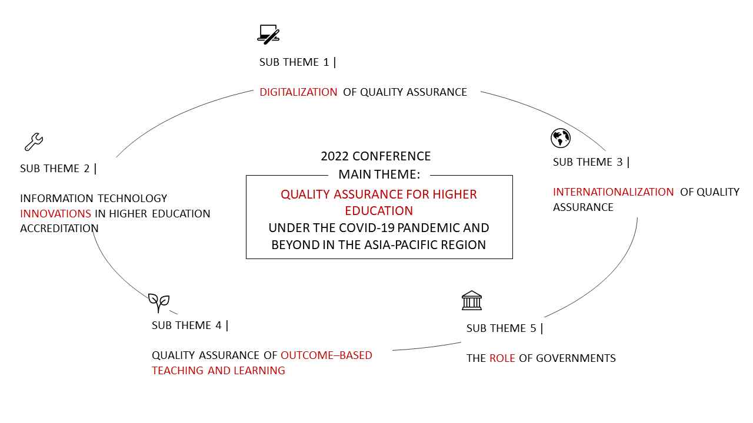
We hope you will join us in both events. Sign up for 2021 AAC and AGM Webinar via the link below and also forward this to any organization / people that you think might benefit from learning more about Quality Assurance and the impact Covid-19 has on Higher Education.
You are invited to submit papers relating to the topic of the 2021 Webinar to be held on November 25， 2021! For those whose submitted papers in 2020 were accepted by the former review panel, please kindly review and modify your former papers accordingly to suit the main theme and submit to us again. Please e-mail your paper to the local organizer <alan@eduvalue.com.sg> as well as APQN Secretariat apqnsecretariat@163.com
Schedule of 2021 AAC and AGM online
Time | Items
June 15, 2021 | The release of the announcement of 2021 and 2022 AAC & AGM, and call for papers for the webinar of 2021 AAC
July 26 - September 26 | 1) Marketing & promotion (with global invitation to submit papers)  2) Online registration is open
September 25 | Deadline for paper submission and the review panel review the papers
September 26 - October 10 | 1)The review panel review the papers  2) Inform the authors the review results  3) Releasing guideline for presentation PPT.
November 1 | Releasing the Programme of the Webinar of 2021 AAC and AGM
November 25 (Thursday), 2021 | Webinar of 2021 AAC and AGM
If you have questions, please contact APQN Secretariat (apqnsecretariat@163.com) and local organizer, EDUVALUE (apqn@eduvalue.com.sg). We are looking forward to seeing you on 25th November 2021 online!
Click on the link below to register
https://www.cognitoforms.com/BAYALLIANCESPTELTD1/apqn2021registrationformonline

APQN Board and the Local Organizing Committee

About the Organiser, APQN
APQN members strive towards dissolving boundaries for a quality region to enhance the quality of higher education in the Asia- Pacific Region through strengthening the work of quality assurance organizations and extending the cooperation between each other. APQN envisions to be a self-sustaining network, a first point of reference for advice or support, efficient in its operations and open in information sharing.

APQN Official Website https://www.apqn.org/

About the Host, EduValue
Strengthening education since 2012 in quality assurance areas, the company retains an undisputed mastery over Quality Assurance (QA) and regulatory compliance. The organization has since grown to provide strategy consultation, digital workflow, human capital, outsourcing of QA functions, management advising, M&A activities and independent audits to identify real gaps that hinder progress and improvement with an overall goal of helping strengthen overall quality for the Education Sector.

EduValue Global Website
https://www.eduvalueglobal.com/
Follow us for more insights
https://www.linkedin.com/company/eduvalueglobal
Keep up-to-date with information about the APQN conference at EduValue Global’s website https://www.eduvalueglobal.com/apqn

